Question 7

ANOVA Results

SST: 408.803

SS_Treatments: 124.540

SSE: 284.263

MS_Treatments: 41.513

MSE: 11.844

F_0: 3.505

Critical F-Value: 3.009

p-value: 0.030746034690146584

Plot of Residuals versus fits

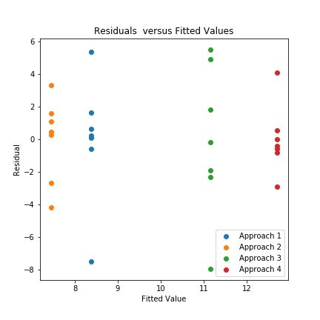

Normal Probability Plot of residuals

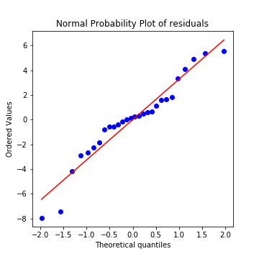

**Answer:** Given that the results of ANOVA yield an F value of 3.505 and F critical is 3.009, there is barely a significant difference in the means.

However, examining the plot of the residuals versus fits we see that the variance between treatments is not as equal as we would like to assume. It appears that approaches 2 and 4 have a variance of about 7 while approaches 1 and 3 have a variance of about 14. This is more of a difference than is comfortable for the ANOVA constant variance assumption.

Additionally, examining the normal probability plot, we see that there are about 3 outliers as well as a cluster of values in the middle that are not quite normally distributed.

Given the nonconstant variance as well as the not quite normal distribution of the residuals, it would be good to further investigate the efficiency of each approach.